
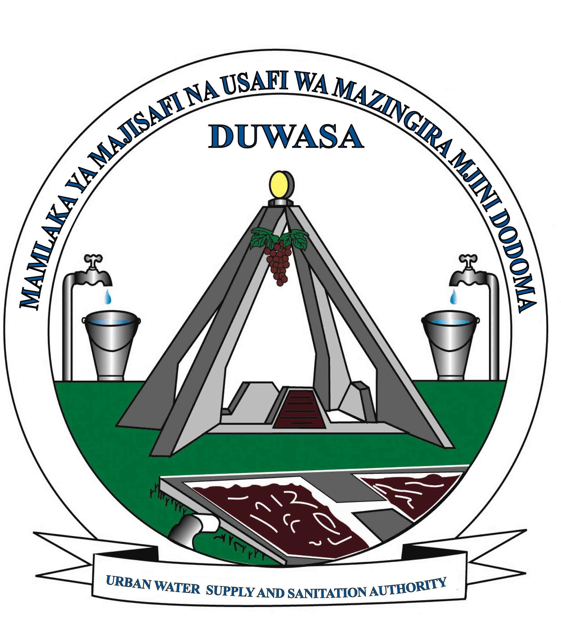
THE UNITED REPUBLIC OF TANZANIA
MINISTRY OF WATER
DODOMA URBAN WATER SUPPLY AND
SANITATION AUTHORITY
(DUWASA)

JOB VACANCIES AT DUWASA
Dodoma Urban Water Supply and Sanitation Authority (DUWASA) is an autonomous water utility legally charged with the delivery of water supply and sewerage disposal services to urban residents of Dodoma City. The Authority was established under section 3(i) of Cap. 272 of 1997 as repealed by Water Supply and Sanitation Act No. 12 of 2009 and Act No. 5 of 2019. It was declared a fully autonomous entity by order of the Minister responsible for water sector on 13th February, 1998; and was officially inaugurated on 1st July, 1998. The Authority has mandate to provide water supply and sewerage disposal services in Dodoma City and Clustered towns of Bahi, Chamwino and Kongwa.

Applications are invited from suitably qualified, dynamic, experienced and performance driven Tanzania male and female, to fill in the following excellent carrier opportunities:

OPERATIONS TECHNICIAN II (5 POSTS):
1.1 Required Qualification (Knowledge, skills and abilities):
Holder of Diploma/ FTC in Civil/Sanitary Engineering or equivalent qualification with three years work experience in water distribution Network and computer application skills.

  - Summary of Duties and Responsibilities:
    - Ensures that all water leakages are repaired promptly.
    - Investigates causes of water loss and makes necessary rectification
    - Reports sewerage pipe faults to responsible officers.
    - Attends to customers complains regarding water shortage and other problems.
    - Performs any other duties as may be assigned by supervisor.

METER READER II (5 POSTS):
  - Required Qualifications (Knowledge, Skills and Abilities):
Holder of Form IV with Trade Test II/I in Plumbing/ Pipe fitter or equivalent qualification with three years’ work experience in plumbing works.

  - Summary of Duties and Responsibilities:
    - Reads all meters allocated to him/her.
    - Keeps track of all meters in the area of operation.
    - Prepares meter reading and customer bills distribution reports.
    - Follows up debts from customers that have not paid their bills.
    - Performs any other duties as may be assigned by Supervisor.

PLUMBER II (5 POSTS):
  - Required Qualifications (Knowledge, Skills and Abilities):
Holder of Form IV with Trade Test II/I in Plumbing/ Pipe fitter or equivalent qualification with three years work experience in plumbing works.

  - Summary of Duties and Responsibilities:
    - Reports all water leakage as assigned.
    - Reports water loss, distribution faults and recommend necessary action.
    - Connects water supply to customers as scheduled
    - Reports unauthorized water connections and maintains records of water theft incidences and witness such incidences in court whenever needed.
    - Carries out water disconnections of debtors and reconnections after payment
    - Disconnects water from customers who are indebted to DUWASA and have not paid their bills on time.
    - Performs any other duties as may be assigned by supervisor.

CUSTOMER SERVICE ATTENDANTS (4 POSTS):
  - Required Qualifications (Knowledge, Skills and Abilities)
Holder of Certificate in Business Administration/Marketing/Mass Communication or any other related qualification with 3 years relevant working experience in a reputable organization and good computer skills. A secretarial skill is added advantages.

  - Summary of Duties and Responsibilities:
    - Assists the Assistant Customer Service Officer in promoting the activities and good public understanding of the Authority.
    - Ensures that new customers are registered in time with the right account numbers in the right zone.
    - Submits accurate water kiosks bills and ensures that the bills are paid on weekly basis.
    - Keeps proper records of new customers.
    - Listens to customers and provides solutions for their problems.
    - Performs any other duties as may be assigned by supervisor.

PUMP OPERATOR II (2 POSTS):
  - Required Qualifications (Knowledge, Skills and Abilities):
Holder of Form IV with Trade Test grade I in Electrical/Mechanical Engineering/Pump Engineering from VETA or equivalent qualification and three years relevant experience as an artisan in the pump house and dam.

  - Summary of Duties and Responsibilities:
    - Operates water pumps according to agreed schedules and ensures that the right quantity of water is pumped from the storage tanks.
    - Monitors water level in the storage water tanks.
    - Ensures that the required dosage of chlorine/chemicals is administered according to the required standards.
    - Records the amount of pumped water at established time intervals.
    - Keeps in safe custody water treatment chemicals and reagents.
    - Advises on the stock level of chemicals.
    - Records the amount of pumped water from booster pump to the distribution network at established time intervals.
    - Performs any other duties as may be assigned by Supervisor.

TERMS OF EMPLOYMENT FOR THE POSTS:
Unspecified Period of Time (Permanent and Pensionable).

AGE LIMIT FOR THE APPLICANTS:
Applicants should not be above 45 years of age.

REMUNERATIONS:
The posts carry attractive remunerations package.

WORKING STATIONS:
DUWASA main office, Chamwino, Kongwa or Bahi stations.

MODE OF APPLICATIONS:
Letter of application accompanied by a detailed CV, Photocopies of relevant certificates; names and addresses of three referees, day contact telephone numbers and postal address should reach the under mentioned address before or on 24th June, 2020.

The Managing Director,
Dodoma Urban Water Supply and Sanitation Authority,
P.O. Box 431,
Tel: 026 – 2324245, Fax: 026 – 2320060,
DODOMA
E-mail: md@duwasa.go.tz

NB: ONLY SHORTLISTED CANDIDATES WILL BE CONTACTED FOR INTERVIEW; AND THOSE WHO WILL NOT HEAR FROM US SHOULD CONSIDER THEMSELVES UNSUCCESFUL CANDIDATES.

“Tanzanian Women are highly encouraged to apply”

